**Secure Link**

<https://secure.esds.co.in/>

1. Click on New to type any data or Information we have to add in secured link.

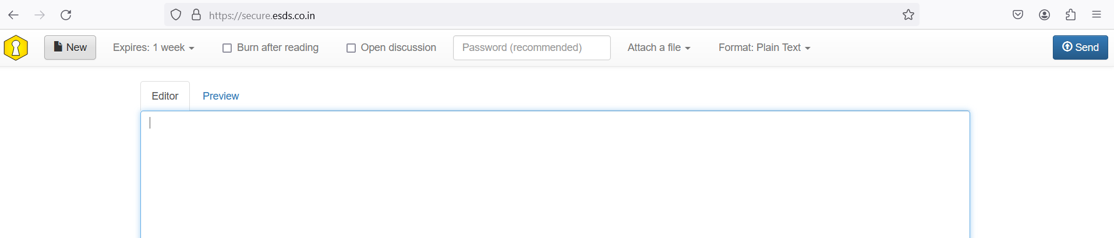

1. To change the expiry of the link which we create, additionally for security we can select the Burn after reading option.

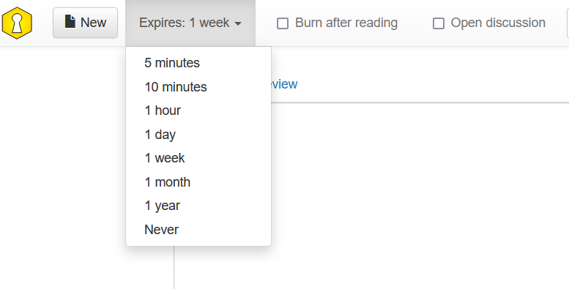

1. Add Image by Attach a file.

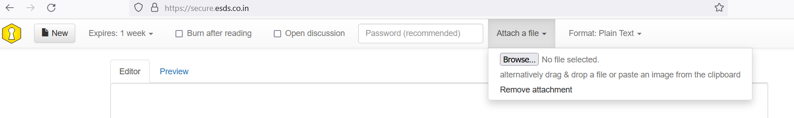

1. Change the file format too if required.

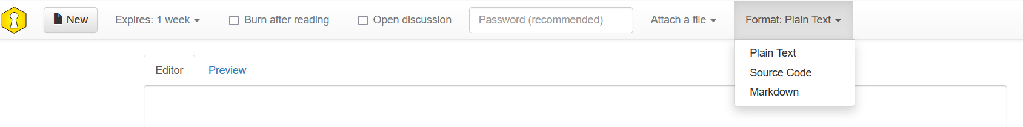

1. Click on send to get the secured link

